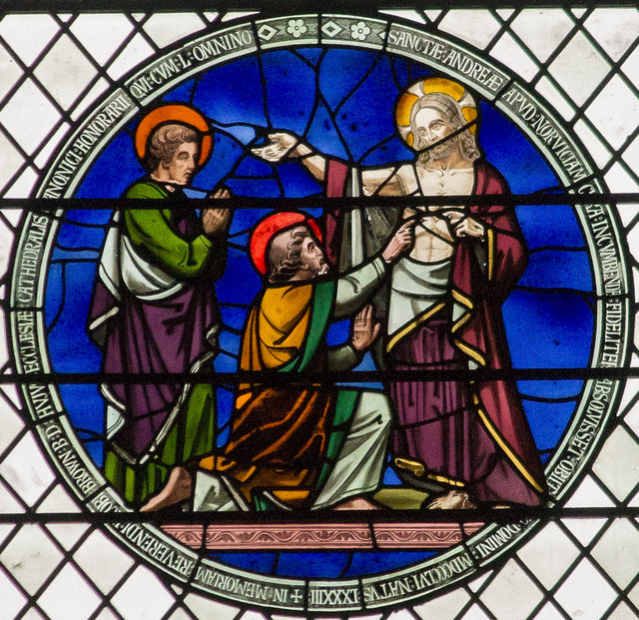

Our Lady of the Presentation
Catholic Church

Chapel and Parish Office location: 17220 Tom Fox Avenue
Church location: 17230 Tom Fox Avenue
Mailing Address: P.O. Box 1, Poolesville, MD 20837
Telephone: 301-349-2045; Fax: 301-349-5423
Website Address: www.olpresentationmd.org
Email Address: olpresentationmd@gmail.com
Office Hours: Mon. thru Thurs. 9am –1pm

April 11, 2021 – Second Sunday of Easter

MISSION STATEMENT

We are a Roman Catholic Parish family united in the Eucharist
• To love others • To grow and share our faith • To welcome all

We are named after the Fourth Joyful Mystery of the Rosary. Our Parish, like Mary and Joseph, comes week after week to present ourselves and our children to the Lord. God, who dwells in our community in the fullness of the Eucharistic Presence, presents Himself to us each day. In all that we do, say, and think at home, in our families, at work, and at play, we seek to make the Presence of God visible to others but, most especially, to those who are in need, be they physical, emotional, or spiritual needs.

STAFF & MINISTRIES

PASTOR: Rev. Justin Huber
DEACON: Rev. Mr. William Stevens
PARISH OFFICE: Ms. Julie Grant
School of Religion: Mrs. Maria
Villarrubia email: OLPdsor@olpresentationmd.org
In Mary’s Footsteps, Sodality: Dr. Nona Colburn,
Mrs. Roberta Margot, Mrs. Anne Beers
Parish Council: Mr. Terry Sullivan
Altar Society: Mrs. Eileen Gilfrich
Married Couples Group: Mr. & Mrs. Rick Sartschev
Liturgy Volunteers: Mrs. Tookie Gentilcore
Finance Council: Mr. Larry Cain
Parish Outreach: Mrs. Roberta Margot, Mrs.
Michelle Brashear

Registration for Parish or School of Religion: Call the Parish Office or download the form at:
www.olpresentationmd.org

SACRAMENTAL LIFE

Schedule of Masses:
Vigil Mass: Saturday 5:30PM in Church
Sunday: 8:00AM & 10:45AM in Church
Weekdays: (Church) 8:30AM M, T, Th, F, Sa
7:30PM W
Baptisms: By appt.- Call the Parish Office
Weddings: By appt.- Call the Parish Office
Sick Calls/Communion: Call the Parish Office
Confessions: Saturday - 4:00-5:00PM
Wednesday – 8:00PM-9PM

Holy Hour/Eucharistic Adoration: for one hour following Wednesday evening Mass.

[Grab your reader’s attention with a great quote from the document or use this space to emphasize a key point. To place this text box anywhere on the page, just drag it.]

