The Presentation of the Child Jesus
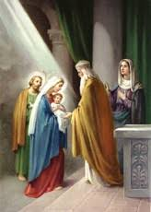

Our Lady of the Presentation’s School of Religion Wish List
- A Slide Projector
- To help make this year's SOR experience more interactive for our children, we are looking for FELT donations. Large swaths (18"x 18" or larger) of yellow, beige and any light colored felt are needed. Smaller pieces (12"x 8") of grape purple, lavender purple, forest green, light green, blue, brown and beige would be greatly appreciated, too. Drop off can be at the rectory office or contact Maria at dsor@ol-presentation-md.org to arrange for a pick up. Thanks for helping our children's Religious Education experiences to be richer! Donations received, thanks!

